This Week’s Highlights
- Debt Ceiling Compromise Is Struck  - Federal Reserve Undecided On Rate Hike Plan / Sees Mild Recession Beginning Q4  - Q1 GDP Revised Higher and April Durable Goods Orders Jump | - Core PCE Data Shows Inflation Remains Sticky  - May Employment Data Released Next Week  - NVDA Strong Earnings Move AI Related Stocks

The S&P 500 closed the week up 0.3% in a move that was enough to push this Index just above key resistance at 4200. In addition, the RSI and Stochastics closed the week in positive territory in a move that keeps the near term uptrend in place. The close above resistance is constructive; however, we’d need to see the S&P 500 post additional gains above this key area to provide confidence that a more sustainable uptrend was in place.

There are several reasons for the need for further rally days above resistance. First is the uncertainty regarding economic growth as well as the potential of interest rate hikes due to incessantly high inflation. In addition, participation in last week’s rally was limited to 2 sectors that outperformed while most areas were under selling pressure.

Should we experience a pullback in the markets, the 50-day moving average is the first area of possible support and at this time, it’s 2.6% away.
The Nasdaq fared quite a bit better with a 2.5% gain that pushed this Index close to its August 2022 high which is the next area of possible upside resistance and is 1.5% away. With the RSI and Stochastics in positive territory, the near term uptrend remains in place.
That said, the Nasdaq closed 3% above its 10-day moving average with the RSI now in an overbought position. In the chart below, you’ll see that a close above the 10-day mav in the 3%+ range has historically preceded a pullback to at least that key moving average.
Gains in the Nasdaq were led by a sharp advance in Semiconductor stocks after bellwether chip company Nvidia’s strong earnings and growth outlook. Select Software stocks also outperformed as did the mega-cap FAANMG stocks.
Both Indices began the week with a pullback that was spurred by the lack of a resolution to the debt ceiling issue as well as weak earnings reports from select Technology and Consumer Discretionary stocks. On Thursday, we saw a sharp rally among AI-related stocks that soared after an earnings report from Nvidia (NVDA) that cited widespread demand for chips that focus on this area.
The rally in AI stocks continued into Friday while defensive areas of the market such as Healthcare, Consumer Staples and Utility stocks remained under selling pressure.
Overall, breadth in the markets deteriorated last week as only 3 of the 11 sectors closed the week in positive territory. Of those, the Consumer Discretionary sector was propped up by mega-cap names Tesla and Amazon while other retail areas came under selling pressure.
Yesterday, a debt ceiling compromise was reached with a House vote expected Wednesday with the Senate set to vote soon after. We anticipate the news will provide a boost for the markets tomorrow.
While the broader markets are in an uptrend, it’s important to remain selective regarding any new positions which is reviewed below. In addition, caution is still advised as may of the crosscurrents we’ve been discussing remain in place.
Technology Sector Gets AI Boost
The Technology sector gained 4.6% for the week in a move that puts this sector within striking distance of an all time high in price reached in December 2021.
Gains in Tech this month have been due to Semiconductor and Software stocks with both areas on track to post returns similar to their strong performances in January this year. (using SOXX and IGV). The primary difference is that this time, the biggest outperformers have been AI-related companies.
Each of the Semiconductor stocks on our List are involved in AI with Nvidia (NVDA) being the most well known. The stock gapped up 24.6% this week after announcing a revenue growth forecast well above Wall Street estimates due to high demand for their AI related GPU’s and chips.
NVDA’s advance puts the stock in an overbought position with the RSI above 90; however, the heavy volume on last week’s rally points to further near term upside as money managers who were caught short accumulate positions. NVDA is in a strong buy zone. Particularly after CEO Huang unveiled a slew of new products including a robotics platform to help the company expand into industries beyond tech.
Other AI related Semis on our Suggested Holdings List gapped up in price last week as well, with Broadcom (AVGO) gaining 19% after analysts upgraded the company’s growth outlook due to Nvidia’s eye opening report.
According to a report from J P Morgan, AVGO has the 2nd highest revenue exposure to AI behind NVDA. It’s 2-day rally put AVGO into an overbought position however again, the high volume points to further near-term upside.
Intermediate term, we anticipate a pullback in these stocks to their shorter term 5-day moving average as they consolidate - provided the markets remain in an uptrend.
For a longer term perspective, review our commentary below where we review similar stocks that have experienced historic gaps up in price following strong earnings. The review will provide helpful insights for formulating a longer-term investment plan. (stocks highlighted are GOOGL 2015, NVDA 2015, META 2023)
Axcelis (ASCL) from our List produces ion implantation equipment which is critical to the fabrication of Semi chips. Increased sales of AI related chips will boost ASCL’s bottom line as well, and the stock is in a strong buy zone following last week’s 14% rally on heavy volume propelled the stock out of a flat base and to new highs.
This week we’re adding Advanced Micro Devices (AMD) to our List after last week’s gains pushed the stock out of a 13-month base on heavy volume. The company produces GPU’s and other AI products with last week’s gains also on the heels of the company’s launch of a new lineup of processors for Google Chromebooks.
AMD is extended on its daily chart and while in a buy zone, intermediate term we anticipate a pullback as the stock is 11% above its 5-day moving average.
For each of the Semiconductor stocks on our List, we anticipate a short lived, near term move higher due to accumulation characteristics among AI related stocks followed by a consolidation phase.
Software stocks also received an AI-related boost with Microsoft (MSFT) from our List gaining 4.6% for the week in a move that has the stock extended above its 5-day moving average. A pullback to this level at $322 would be an ideal buy point. MSFT’s major investment in OpenAI runs on their Azure cloud computing platform and stands to benefit greatly from increased adoption of AI.
Elsewhere on our List, Salesforce (CRM) recovered from an early week pullback after a Wall Street upgrade to its price target pushed the stock higher on above average volume. CRM can be bought on a pullback to its 5-day moving average at $210.
Datadog (DDOG) posted a more modest 1% gain for the week amid a consolidation phase which is following a multi-week rally after reporting strong earnings and a positive outlook. DDOG can be held.
Uber Technologies (UBER) pulled back from a near-term high in price on Monday where it found support at its upward trending 21-day moving average. The stock is in a buy zone as it closed the week above its shorter term moving averages.
Apple (AAPL) pulled back to its 21-day moving average as well, before buyers came in and pushed the stock into a strong buy zone with a close above its 5 and 10-day moving averages. Wall Street is anticipating the release of Apple’s mixed reality headset at their Worldwide Developers Conference on June 5th which may give the stock a push higher.
The Technology sector is now in an overbought position after two successive weeks of outperformance. While AI exuberance may continue to buoy this sector, earnings from select Software and Semiconductor stocks next week may temper the upbeat mood.
Going forward, hints of higher interest rates would be a negative for this sector and next week’s key employment data will be closely watched. Longer term however, the Tech sector is setting up to continue to be a leadership area for the markets.
Healthcare Sector Breaks Below Key Support
Healthcare stocks were among the worst performing last week with a decline on above average volume that points to the further near term downside.
Selling in this sector has intensified amid groundbreaking changes in how Medicare buys drugs. The change is due to the Inflation Reduction Act or IRA bill that was passed late last year and is aimed at reducing costs for drugs. The impact has already begun as the government rebate for 30 drugs was recently reduced.
The new reduced pricing does not directly impact healthcare companies on our List; however, the uncertainty surrounding future adjustments has pushed these stocks lower. Merck (MRK) fell 3.8% last week after the company’s CFO recently spoke of pricing concerns going forward for drugs such as their cornerstone cancer treatment Keytruda.
Last week’s break below its 50-day moving average has us removing Merck (MRK) from our List as the RSI and MACD are now in negative territory.
Astrazeneca (AZN) was able to recover from a pullback below its 50-day moving average after reporting positive results regarding clinical trials for several major drugs. AZN can be held.
Intuitive Surgical (ISRG) fared better than its peers with a 2% decline for the week. The stock recovered from a Tuesday pullback to close the week just below its 10-day moving average. The stock can be bought on a move above its 5-day moving average at $306.
Biogen (BIIB) pulled back as well, and the stock was able to find support at its 50-day moving average. While the RSI is in negative territory, the MACD has remained positive and is trending toward a possible positive crossover. (black line up through the red). BIIB can be bought once the stock closes above its shorter term 10 and 21-day moving averages.
While the IRA bill has already begun to impact drug companies that are facing lower rebates from government funded healthcare insurance, larger impacts are in store and will not be known until Medicare negotiations begin this September. The uncertainty has hit Biotech and Pharmaceutical companies which are now in a downtrend.
The prospects of reduced drug pricing being mandated by a non-negotiable entity such as the U.S. Government will continue to put a cloud over Pharmaceutical and Biotech companies. We would underweight stocks in this sector.
Consumer Discretionary Sector Inline With Markets
A late week rally in heavyweights Tesla (TSLA) and Amazon (AMZN) put the Consumer Discretionary sector higher by 0.3% for the week. Beyond these stocks, it was a tough period elsewhere with footwear, clothing and restaurant stocks all down over 4% while travel and leisure related stocks fell 3%.
The decline in these consumer facing stocks is occurring amid a string of weak earnings and/or outlooks from Retailers with commentary from these companies becoming even more downbeat.
Some of the largest retailers have highlighted the shift among consumers from discretionary items to lower-margin essential ones with companies such as Target (TGT) reporting a slowdown in sales trends over the past 2 months. Costco (COST) reported results last week that were below estimates.
Another challenge has been persistently high rates of inflation while theft has also been cited as a cause for slower growth.
Despite these challenges, Walmart (WMT) raised their sales forecast for 2023 however, the stock has not remained immune to selling pressures elsewhere. Last week, the stock fell 2.5% and is now below its 50-day moving average. In addition, the RSI and MACD are now in negative territory on the daily chart.
We’re removing WMT from our Suggested Holdings List however of note, the longer-term weekly chart remains intact as the stock closed above its 10-week moving average with its MACD and RSI in positive territory. Longer term investors can remain with the stock.
Wingstop (WING) pulled back last week and closed below its 10 and 21-day moving averages. It’s tight trading range over the past 3 weeks has been on light volume and can be viewed positive. A close above its recent high of $210 on volume would put WING into a strong buy zone.
Housing stocks pulled back last week as mortgage rates continue to inch higher. Mortgage rates are most impacted by inflation and Friday’s news of higher than expected PCE data shows that inflation remains high.
Not all of the news is poor for this group however with Toll Brothers (TOL) gapping up in price after reporting strong earnings while raising estimates quite a bit higher going forward.
KB Home (KBH) from our list ended the week with a rally that puts the stock close to regaining its 10 and 21-day moving averages. A close above its 10-day moving average - which is 0.5% away - would put the stock into a buy zone.
Next week, housing stock Hovnanian Enterprises (HOV) is due to report earnings and results may impact other names in the home building group.
Communication Services Sector Remains In Confirmed Uptrend
Internet related stocks continue to buoy this sector with last week’s outperformance in heavyweight names Alphabet (GOOGL) and Netflix (NFLX) helping to keep this group in an uptrend.
GOOGL from our List received several Wall Street upgrades last week due to launching a new generative AI capacity in search as well as experimenting with placing ads directly in AI chatbot.
The stock is in a strong buy zone as it finds support above its upward trending 5-day moving average. Last week’s analyst upgrades were due mainly to Alphabet’s advanced involvement in AI related projects which are expected to drive already strong revenues higher.

BREAK OLD TEXT

BREAK OLD TEXT

The S&P 500 fell 3.3% for the week in a move that puts this Index further below its 10-day moving average. With the RSI and Stochastics firmly in negative territory, the near-term outlook for the S&P 500 is negative. As noted last week, the next area of downside support for this Index is the 3853 level which is the low from March 25th 2021.
Currently, we’re 1.2% above this possible area of support. More major support for the S&P 500 is in the 3700 range which is the lows from earlier in the 1st quarter of 2021, and is currently 5% below Friday’s close.
M
of Technology outside of mega-cap names that are viewed as more predictable.
Industrial Sector Remains Under Pressure
Economically sensitive Cyclical stocks such as Industrials were hit again this week as investors appear to be turning less positive on the pace of a global economic recovery.
Last week, China reported that their economy grew more slowly than expected in the 2nd quarter due to higher raw material costs and new Covid breakouts. The potential loss of momentum in China’s economic growth is cause for concern elsewhere given they’re the world’s 2nd largest economy.
In the U.S., bellwether Industrial stocks such as Caterpillar (CAT) and Deere (DE) remain in confirmed downtrends despite estimates for earnings growth well above 50% for this year.
Northrop Grumman (NOC) from our List fell in line with other Defense stocks in a move that pushed the stock back below its 50-day moving average. With the RSI now in negative territory, we’re removing the stock from our List.
United Parcel (UPS) fell slightly and can be held as the stock found support at its 50 day moving average. Further deterioration could easily push the RSI into negative territory which would have us removing the stock.
Communication Services Sector Trades In Line With Markets
This sector exhibited weakness that was similar to the broader markets however, the Stochastics - a faster moving momentum indicator - is now negative for Communication Services, which may signal more general weakness over the near term.
The Internet Related group - led by Alphabet (GOOGL) and Facebook (FB) - is the largest part of this sector and next Wednesday, widely watched Twitter (TWTR) is due to report their earnings. Their numbers as well as the markets reaction may set the pace for this group.
Last week, Alphabet (GOOGL) handily outpaced its peers with a 1.2% gain. The outperformance is in line with a continuation move into mega-cap Tech stocks that have the potential to produce solid growth regardless of inflationary pressures.
GOOGL is in a buy zone as the stock has repeatedly shown that it can be bought on a pullback to its 10-day moving average.
Consumer Discretionary Sector Among Worst Performers
Discretionary stocks sold off sharply as increased cases of the Delta variant of Covid hit Travel and Leisure Related stocks which fell an average of 7% for the week.
Retailers also took it on the chin as record inflation levels pushed consumer sentiment down.
Heavyweight stock Amazon (AMZN) which we recently added experienced a sharp pullback. As cited last week, the stock was in an overbought position on its daily chart and last week’s decline has the stock close to finding support at its 21-day moving average. A break below this level would not be good for the near-term prospects for AMZN.
The weekly chart of AMZN continues to point to a bullish longer term view as the stock broke out of a 10-month base last week with both momentum indicators in a positive position.
Discount Retailer Ross Stores (ROST) saw heavy distribution on Friday which was when June’s negative Consumer Sentiment report was released. The stock decisively broke below each of its moving averages on volume and we’re removing the stock from our List.
Retailers Dicks (DKS) and Boot Barn (BOOT) also experienced selling and at this time, both stocks are finding support at their 50-day moving averages. A break below this level will have us removing the stocks from our List as sentiment surrounding the prospects for Retailers will trump the strong growth prospects for both of these stocks.
Recently added Starbucks (SBUX) posted a gain for the week which pushed the stock out of a 3-month base. The ability for this stock to withstand deterioration elsewhere among consumer related stocks, highlights investors favoring larger, more established firms that may be better able to weather an uneven economic recovery.
Big box stores Target (TGT) and Costco (COST) both also held in well last week.
Pool Corp (POOL) is due to report their earnings on Wednesday. The company has reported year over year earnings growth of over 200% during the last 2 quarters and next week’s report is expected to be equally strong given easy comparisons to last year’s “bear market” quarter.
----------------------------BREAK OLD TEXT---------------------------
The S&P 500 edged to a new high in price with a 0.4% gain. A Thursday pullback on global growth concerns, helped push the RSI out of an overbought position. With the Index bullishly regaining its 10-day moving average on Friday, the near-term uptrend for this Index remains in place.
As noted last week, we’re using the April into May period as precedence for the current period for the S&P 500 Index.
A daily chart shows that the Index remained above its key 10-day mav during the 4% rally which took place before a mid-May pullback occurred on the heels of high inflation readings.
The Nasdaq experienced a similar gain for the week led by select FAANMG stocks that are continuing to come under accumulation. Software stocks also outperformed the markets.
The holiday shortened week saw Growth stocks outperform again and while Cyclical stocks didn’t fare as well, a Friday rally in Materials and Industrials helped push these sectors above their shorter term moving averages.
Treasury yields took center stage as a steep decline earlier in the week helped boost Growth stocks which fare better when interest rates are falling. Investor sentiment shifted later in the week, as the spread of the delta variant of Covid dimmed growth outlooks.
This movement in response to every headline is indicative of the summer months as lighter volume due to vacationing money managers, allows more volatility to take place.
Overall, economic data released last week supports the view that the economy is still expanding but not at a torrid pace that would spark inflation fears.
Cyclical stocks continued to underperform however, there are signs that these areas are beginning to turn around. We’ll need to see more of a broadening out of participation in Industrials, Financials and Materials before considering adding stocks to these areas.
Next week, earnings season will begin with several Large Cap Bank stocks due to release their 2nd quarter results. Not only will it impact other banks depending on the reports, but oftentimes these initial reports can set the stage for the remainder of earnings season.
In particular, a bullish response to positive results is bullish as is any lack of response to flat results.
Technology Sector Outperforms
The Tech sector outperformed the markets yet again led by heavyweight stock Apple (AAPL) which gained 4% for the week. The gain pushed the stock out of a 5 ½ month base breakout and to a new high in price.
AAPL is continuing to find support at its upward trending 5-day moving average and while the RSI overbought on its daily chart, the weekly chart shows the MACD having a bullish crossover from a relatively low level.
The weekly chart is ideal for an intermediate outlook and AAPL currently looks attractive on both a shorter and longer term basis.
Elsewhere in Tech, Software stocks outperformed for the week led by Cybersecurity related names such as Crowdstrike (CRWD) which was a top performer. Its 5% gain pushed the stock further above its recent 5-month base breakout and the stock is in a buy zone as it finds support at its 5-day moving average.
Security related stocks rallied following news of a large ransomware attack on IT company Kaseya which has government as well as other major company contracts. Studies show that protection against cyber attacks is one of the top budget items for most corporations.
With CRWD being established as a leader in this space, we expect the stock to continue to outperform with its short and long term charts currently in an attractive position.
HubSpot (HUBS) and Adobe (ADBE) , which we additionally identified as being in a buy zone last week, also outperformed the group. ADBE and HUBS both bullishly continue to find support at their 5-day moving average.
While ADBE is overbought on its daily chart, historical precedence shows that it can remain in this position for some time. A break below its 5-day mav with a negative MACD crossover would indicate the beginning of a pullback.
We’re adding Software stock ServiceNow Inc. (NOW) to our Suggested Holdings List following last week’s 9-week base breakout ahead of the release of their earnings later this month.
While the NOW’s RSI is overbought on its daily chart, the weekly chart experienced a MACD crossover into positive territory which last occurred in May of last year which preceded a lengthy rally. The stock can be bought in the $560 range.
Arista Networks (ANET) broke out of a 3-week base on volume following a major Wall Street upgrade with a $420 price target. The company is seeing improved revenues as major clients such as Facebook and Microsoft are upgrading to ANET’s latest networking services.
ANET is in a strong buy zone.
Semiconductor stocks were down as much as 3% last week before a Friday rally regained half of the losses. While Semi’s produce a lot in the way of earnings and sales growth, they are ultimately viewed as Cyclical in that they fare well during periods of economic expansion.
Last week’s news of global spreading of the Delta variant of the coronavirus dampened economic growth outlooks and in turn pushed these stocks lower.
Equipment stocks fared the worst with Applied Materials (AMAT) breaking below its 50-day moving average before regaining this key mav on Friday. We would need to see a break back above its 10 and 21-day moving averages before turning positive on the stock.
Nvidia (NVDA) and Marvel (MRVL) received price target upgrades last week as analysts raised growth prospects for both companies.
NVDA and MRVL are both a hair away from being in strong buy zones with a break above the 10-day being positive for MRVL while NVDA would need to get back above its 5-day mav.
Several well known Semiconductor stocks are due to report earnings later this month which will shed more light on the positive prospects for this group.
Microsoft (MSFT) was flat for the week following news that the Pentagon was cancelling their cloud computing contract with the company. MSFT is in an overbought position on both its daily and weekly chart and a period of consolidation at this juncture would be healthy for the stock by allowing it to set up for another leg up.

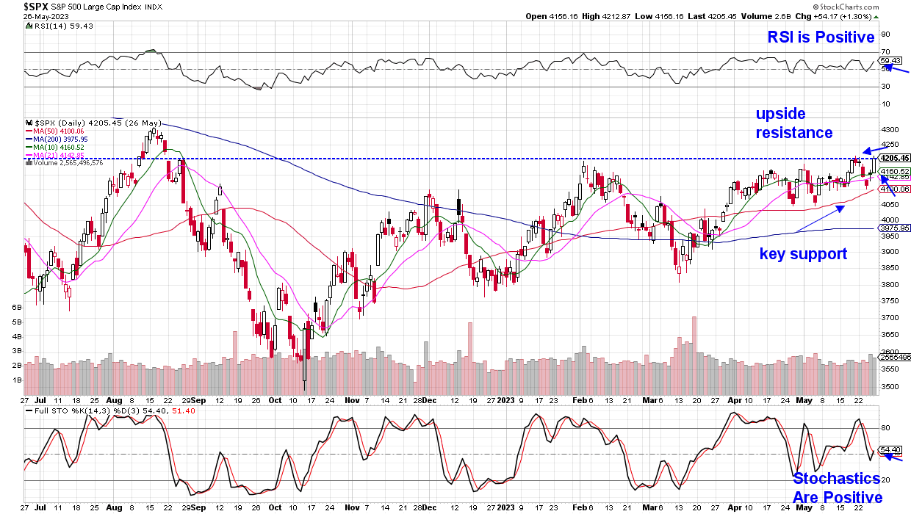

Daily Chart of S&P 500



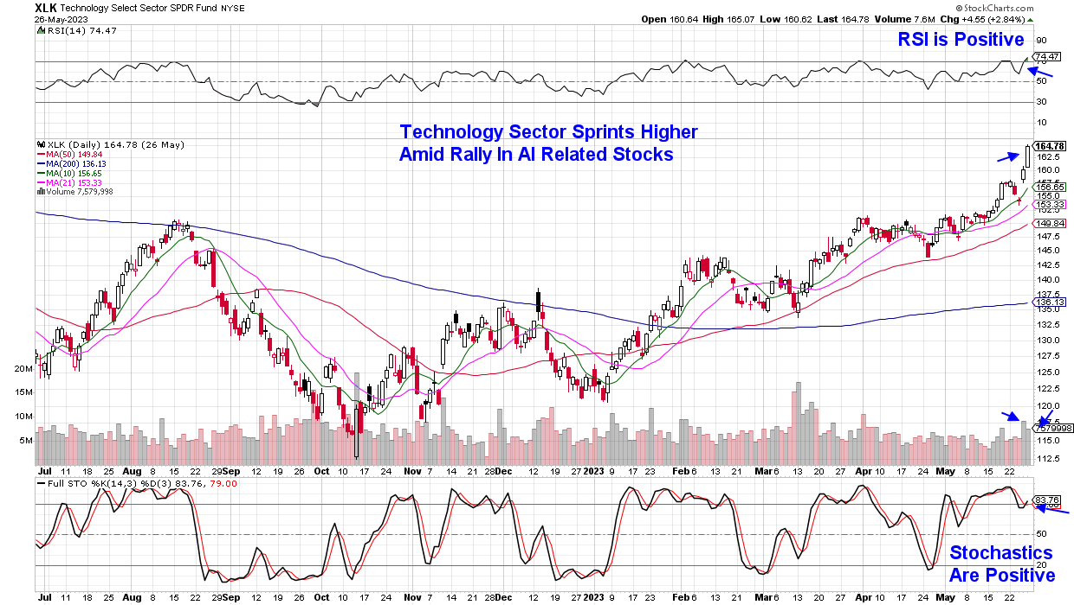

Daily Chart of The Technology Select Sector SPDR Fund (XLK)

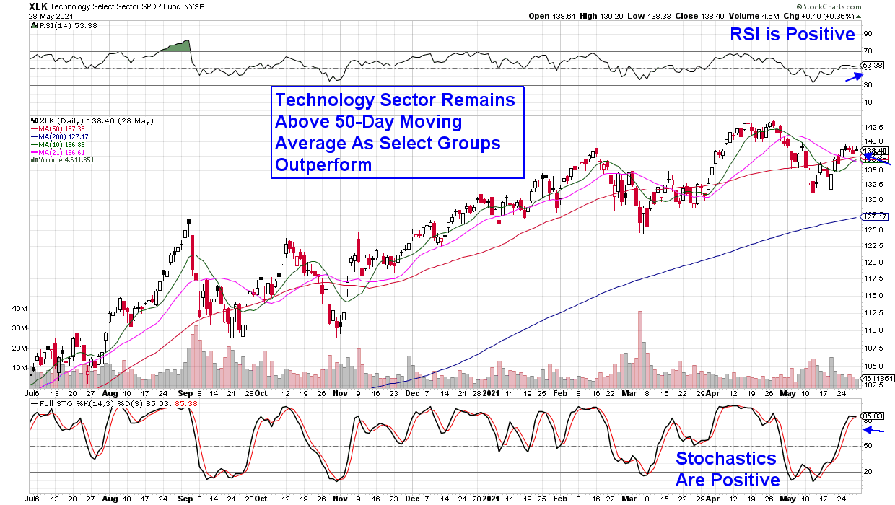

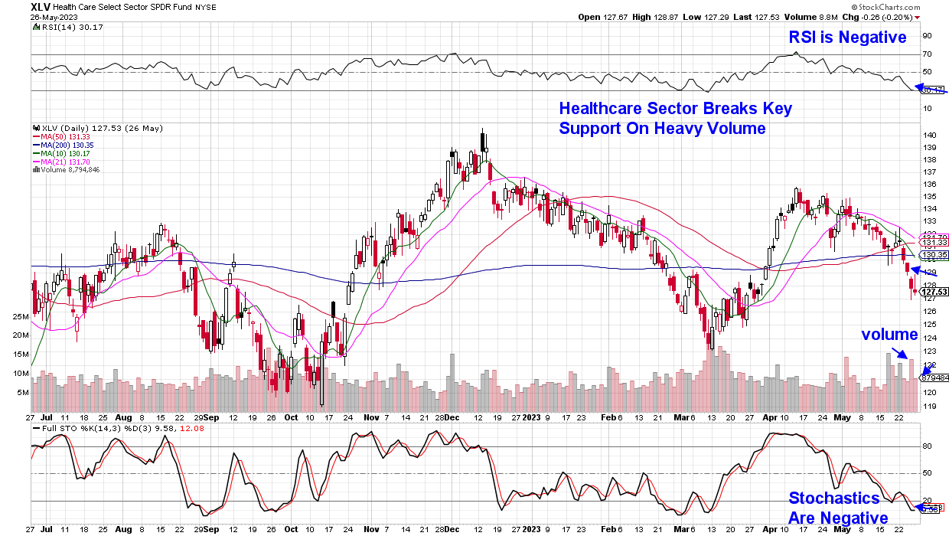

Daily Chart of The Health Care Select Sector SPDR Fund (XLV)
Daily Chart of Technology Sector

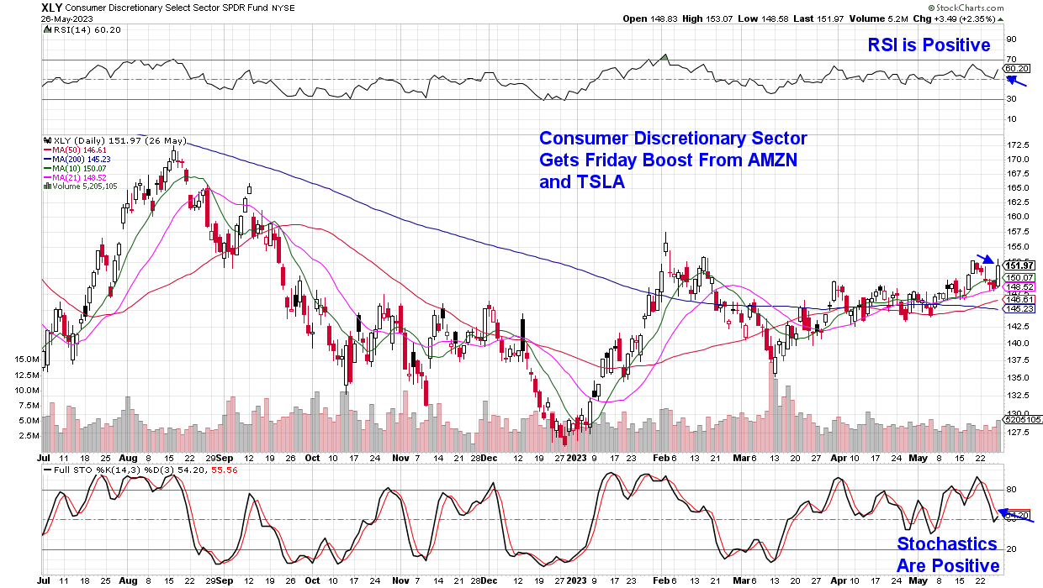

Daily Chart of the Consumer Discretionary Select Sector SPDR Fund (XLY)
/

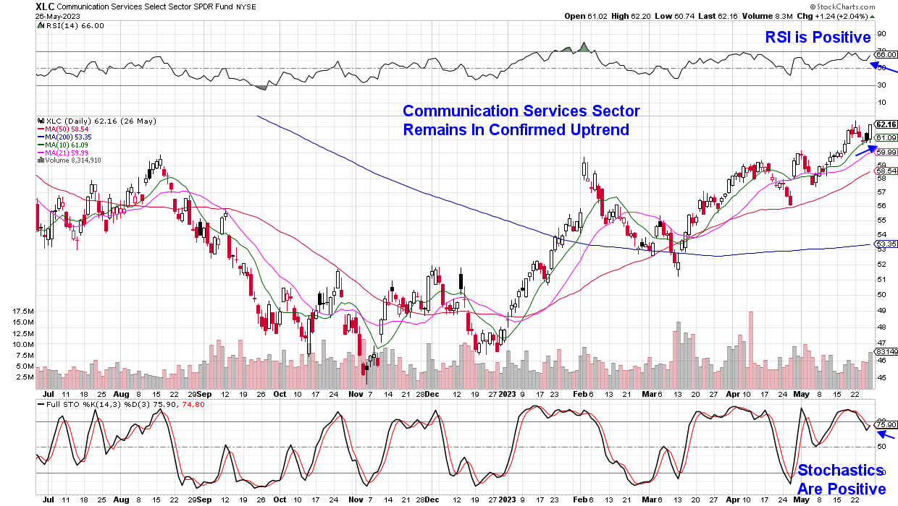

Daily Chart of Communication Services Select Sector SPDR Fund (XLC)
Summary
Last week’s action in the markets was mixed given that we began on a weak note which was reversed following a stunning earnings report from leading Semiconductor stock Nvidia (NVDA). The ensuing rally on Thursday and Friday was strong but selective, as AI-related stocks received a considerable boost while other areas sold off or generally underperformed.  Next week, we anticipate a continued bifurcation in the markets with AI related stocks continuing to bask in the glory of Nvidia’s strong growth forecast while Retail, Healthcare and Financials continue to struggle under the weight of their select issues.  With earnings season mostly behind us, investors will again focus on the Feds possible monetary policy path ahead of their June 14th meeting. Last Friday’s strong inflation report was ignored by investors as AI news took center stage; however, it may be brought back to the forefront with next Friday’s employment data taking center stage as well.  . | This weekend’s debt ceiling compromise may spark a slight rally in the markets however, Wednesday’s vote may not prove to be as generous. Once the debt ceiling is raised, the Treasury will begin to raise money by selling large quantities of bonds which in turn, will put upward pressure on interest rates.  For now, we would remain selective when initiating any new positions with a focus on AI related stocks from our List that are poised for further near term upside due to accumulation characteristics amid strong growth prospects.

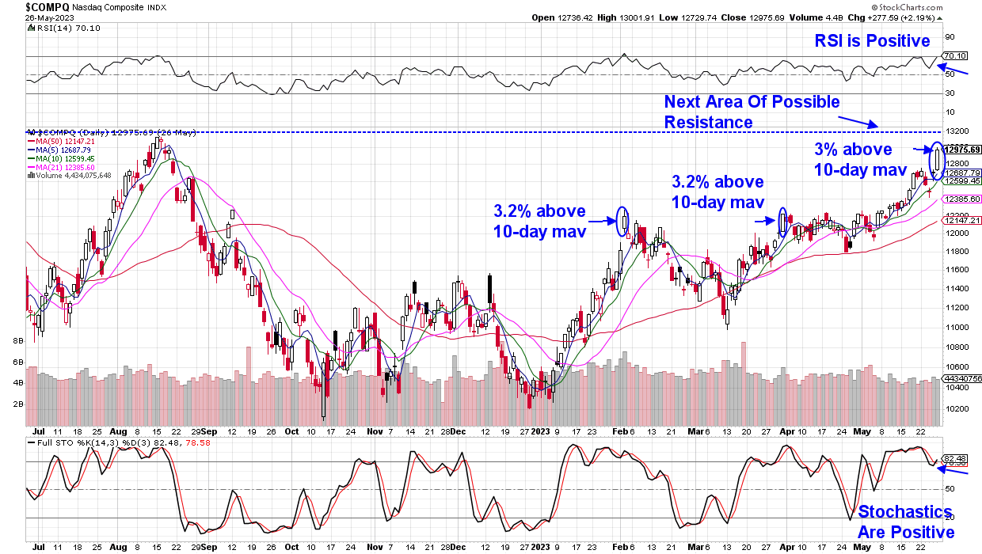

Nasdaq Composite ($COMPQ)

Google’s rally on July 17th 2015 which at the time, was the biggest in history after a 16% gain on the heels of a strong earnings report, is another example. The stock held the gap up for a week before a flash crash in the markets took the stock down with it.
Meta Platform’s (META) earnings-driven advance in late January of this year also came under pressure in
February as selling ensued in the markets. A 2nd gap up in price after earnings in late April of this year was followed by a market related pullback before the stock rallied to new near term highs once market pressures receded.

However, if the markets are not in a downtrend, we can use the 5-day moving average as an entry point. (see chart below of NVDA from 8 years ago)
Historical Precedence Of Gaps Up In Price Among Mega-Cap Stocks After Reporting Earnings
A look at similar stocks that have experienced a gap up on earnings tells us that a downward shift in broader market direction will be an overriding influence of a stock's downward price movement after earnings.

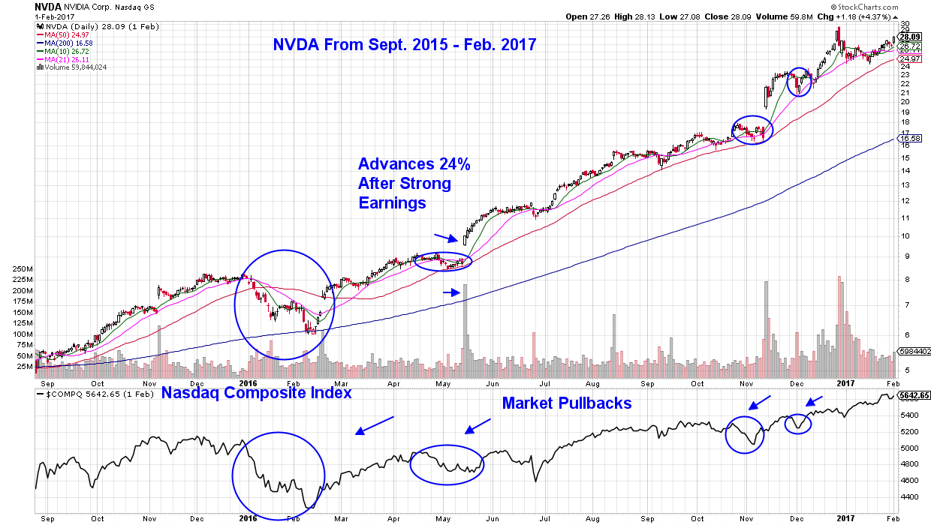

Daily Chart of NVDA - SEPT 2015 – FEB 2017
MEM Edge Report Suggested Holdings
Stocks With Emerging Leadership Characteristics
$ = Earnings Due | Buy Zone | Strong Buy | Buy on Pullback | Removed From List

SYMB | COMPANY | PRICE | DATE ADDED | PERFORMANCE |  |  | EARNINGS  DUE DATE | INDUSTRY GROUP
CONSUMER DISCRETIONARY
KBH | K B Home | $41.70 | 4/23/2023 | 4.0% | Sept 20 |  |  | Residential Builder
WING | Wingstop Inc. | $157.80 | 1/29/2023 | 23.0% | Aug 9 |  |  | Retail Restaurant
WMT | Walmart | $147.50 | 4/02/2023 | 0% | Aug 15 |  |  | Retail Discount

COMMUNICATION SERVICES
GOOGL | Alphabet | $108.80 | 4/16/23 | 16.0% | July 24 |  | Internet Content

HEALTHCARE
AZIN | AstraZeneca ADR | $72.30 | 4/09/2023 | -2.0% | July 27 |  | Medical Diversified
BIIB | Biogen | $318.00 | 5/07/2023 | -6.0% | July 25 |  | Medical Biotech
ISRG | Intuitive Surgical | $300.22 | 4/23/2023 | 0.5% | July 18 |  | Medical Equipment
MRK | Merck & Co. | $115.30 | 4/16/23 | -7.0% |  |  | Medical Drugs

TECHNOLOGY
AAPL | Apple | $106.30 | 3/26/2023 | 11.0% |  |  | Telecom – Cons Products
ACLS | Axcelis Technologies | $137.00 | 5/17/2023 | 17.0% | Aug 4 |  | Semiconductor
AMD | Advanced Micro Devices | $127.00 | 5/29/2023 |  | Aug 3 |  | Semiconductor
AVGO | Broadcom | $657.50 | 5/17/2023 | 23.0% | Aug 2 |  | Semiconductor
CRM | Salesforce | $209.40 | 5/17/2023 | 2.5% | May 31 |  | Software
DDOG | Datadog | $81.80 | 5/10/2023 | 8.0% | Aug 4 |  | Software
MSFT | Microsoft | $276.20 | 3/16/2023 | 17.0% | July 25 |  | Software
UBER | Uber Technologies | $437.80 | 5/07/2023 | 2/0% | Aug 2 |  | Software
NVDA | Nvidia Corp | $178.40 | 1/22/2023 | 84.0% | Aug 24 |  | Semiconductor

Glossary of Terms Used From Our Suggested Holdings

Buy Zone
This means the stock is in a confirmed uptrend and is finding support at its upward-trending key moving averages and can be bought. If you own the stock, stay with it.
Strong Buy
This means we have slightly more conviction in the ability of this stock to outperform the markets over the next week. The stock may be poised to break out of a base, it may be in a strong industry group or there may be recent good news. In other words, the stock has some edge that should help propel the stock higher.
Buy on Pullback
In this case, the stock is a bit over-bought (or extended) and may need to come in a little before buying. This is usually following a particularly strong week where the stock was up a lot. We would look for a pullback to the stock’s upward-trending 10-day moving average as an optimal entry point.
Not Highlighted
These are stocks that remain positive and can be held if you own them. However, they currently do not appear poised to have an upward move. The stock may be consolidating after a large advance or be in an industry group that is not in favor. The longer-term uptrend remains in place however.
Disclaimer: This publication “MEM Edge Report” is published by MEM Investment Research, LLC, and is both proprietary and intended for the sole use of subscribers. No license is granted to any subscriber, except for the subscriber’s personal use. No part of this publication or its contents may be copied, downloaded, stored in a retrieval system, further transmitted, or otherwise reproduced, stored, disseminated, transferred, or used, in any form or by any means, except as permitted under the subscription agreement or with the prior written permission of MEM Investment Research, LLC. Any further disclosure or use, distribution, dissemination or copying of this publication, message or any attachment is strictly prohibited. MEM Investment Research, LLC is a financial publisher who publishes information about markets, stocks, industries, sectors and investments in which it believes sub-scribers may be interested. The information in this letter is not intended to be personalized recommendations to buy, hold or sell investments. MEM Investment Research, LLC is not permitted to offer personalized trading or investment advice to subscribers. Employees of MEM Investment Research, LLC may own positions in stocks mentioned or highlighted in THE MEM Edge Report. The information, statements, views and opinions included in this publication are based on sources (both internal and external sources) considered to be reliable, but no representation or warranty, express or implied, is made as to their accuracy, completeness or correctness. Such information, statements, views and opinions are expressed as of the date of publication, are subject to change without further notice and do not constitute a solicitation for the purchase or sale of any investment referenced in this publication. By using the information in THE MEM Edge Report, or from MEM Investment Research, LLC, or www.meminvestmentresearch.com, you assume full responsibility for any and all gains and losses, financial, emotional or otherwise, experienced, suffered or incurred by you. SUBSCRIBERS SHOULD VERIFY ALL CLAIMS AND DO THEIR OWN RESEARCH BEFORE INVESTING IN ANY INVESTMENTS REFERENCED IN THIS PUBLICATION. INVESTING IN SECURITIES AND OTHER INVESTMENTS, SUCH AS STOCKS, OPTIONS AND FUTURES, IS SPECULATIVE AND CARRIES A HIGH DEGREE OF RISK. SUBSCRIBERS MAY LOSE MONEY TRADING AND INVESTING IN SUCH INVESTMENTS.

